SLAM Line Guard Rail System
Handoff, Continuation, and Maintenance Guide
Johnny Poole
AMM Intern, RME Engineering
TPA4-SFC — Temple Terrace, FL
August 2026

I. Introduction
This document provides detailed guidance for the continuation, maintenance, and future expansion of the SLAM Line Guard Rail system. It is intended for any technician picking up this project and contains everything needed to install new assemblies, maintain existing ones, and update the Configuration Tool.

II. Project Status
The prototype guard rail assembly was installed on SLAM Line 501 on August 3, 2026. Post-installation monitoring (8 reporting days) confirmed a 47% reduction in package drops at the installed section. The system is fully functional with no structural issues. Phase 2 (expansion to remaining locations) is ready for continuation.

III. Key Contacts
Role | Name | Email | Slack
Recommended Technician for New Ownership | Jean Simeon | jesimeo@amazon.com | jesimeo
Mentor | Kishan Patel | kishptl@amazon.com | kishptl
Manager | Jon Templeton | templetj@amazon.com | templetj
Project Author | Johnny Poole | jtpoole@amazon.com | jtpoole

IV. Project Files
All project files are stored in the SLAM Guard Rail Project folder:
- Engineering Design Report — SLAM Guard Rail Report.docx
- Configuration Tool — Config Tool Files\SLAM Guard Rail Configuration Tool.html
- Configuration Tool Backup — Config Tool Files\SLAM Guard Rail Configuration Tool (DO NOT EDIT).html
- Knowledge Transfer File — Config Tool Files\SLAM Config Tool — Knowledge Transfer.txt
- Panel Aligner Bracket STL — project files folder (ready to print, same for all installations)
- Excel Data — SLAM Gaurd Rail Project.xlsx
Note: The "DO NOT EDIT" backup preserves the working Configuration Tool as of project handoff. If future updates break the tool, this file is available as a known-good restore point.

V. Tools and Materials Required

Tools
- Allen wrench (5mm hex — standard for M8 bolts)
- Drill + 9mm drill bit
- 3/4" counterbore bit (drill approximately 6mm deep)
- Paint marker (for center marking with panel aligner brackets)
- Tape measure

3D Printing Settings
- Material: PLA
- Infill: 50% or higher
- Layer height: 0.2mm
- Parts: spacers (generated from Configuration Tool) + panel aligner brackets (STL in project files or downloadable from tool)

VI. Using the Configuration Tool
The Configuration Tool is an HTML file that runs in any browser with no installation required. It generates all the information needed to build a guard rail assembly for any location.

Required Measurements (take at the target location)
- Height difference — Vertical distance between the top of the mounting bracket and the top of the conveyor belt. Positive = bracket above belt, negative = bracket below belt.
- Mounting hole to belt edge — Horizontal distance from the center of the slot/hole (that will be used to install the assembly) to the edge of the conveyor belt.
- Total guard rail length — The total length the assembly needs to be to cover the unguarded section.
All other input fields in the tool should be left at their default values unless there is a specific reason to change them for the target location.

Tool Outputs
- Panel layout and cut lengths
- Drill guide with exact hole positions
- Complete materials list
- Spacer STL (download and print)
- Panel Aligner Bracket STL (also available in project files)
- T-nut position map
- Structural analysis (FOS validation)

VII. Assembly and Installation Instructions
Estimated total time from start to installed: approximately 4 hours (including 3D print time).

Step 1: Fabrication
- Cut the ABS panel(s) and aluminum extrusion rail(s) to the lengths specified by the Configuration Tool.
- Drill counterbores (3/4" bit, ~6mm deep) at each bolt position marked on the drill guide.
- Drill 9mm through-holes in the center of each counterbore.
- Print the 3D printed parts: spacers (from Configuration Tool STL) and panel aligner brackets (from project files STL).
- The panel aligner brackets have built-in center markers. Place brackets at the top of the panels where two panels meet (bracket edge aligned with or near the top edge of the panels). Use a paint marker on the center markers to mark drill positions on the panels.
- The center markers are designed to break off easily — push an M8 bolt through them to remove.
- Drill the marked positions on the panels using the same counterbore + 9mm through-hole process.

Step 2: Pre-Assembly (Panels + Hardware)
- Loosely attach hardware to the panel(s) in this order: M8 bolt through panel hole → spacer (if needed) → T-nut.
- Leave bolts loose enough that the aluminum extrusion can slide onto the T-nuts.
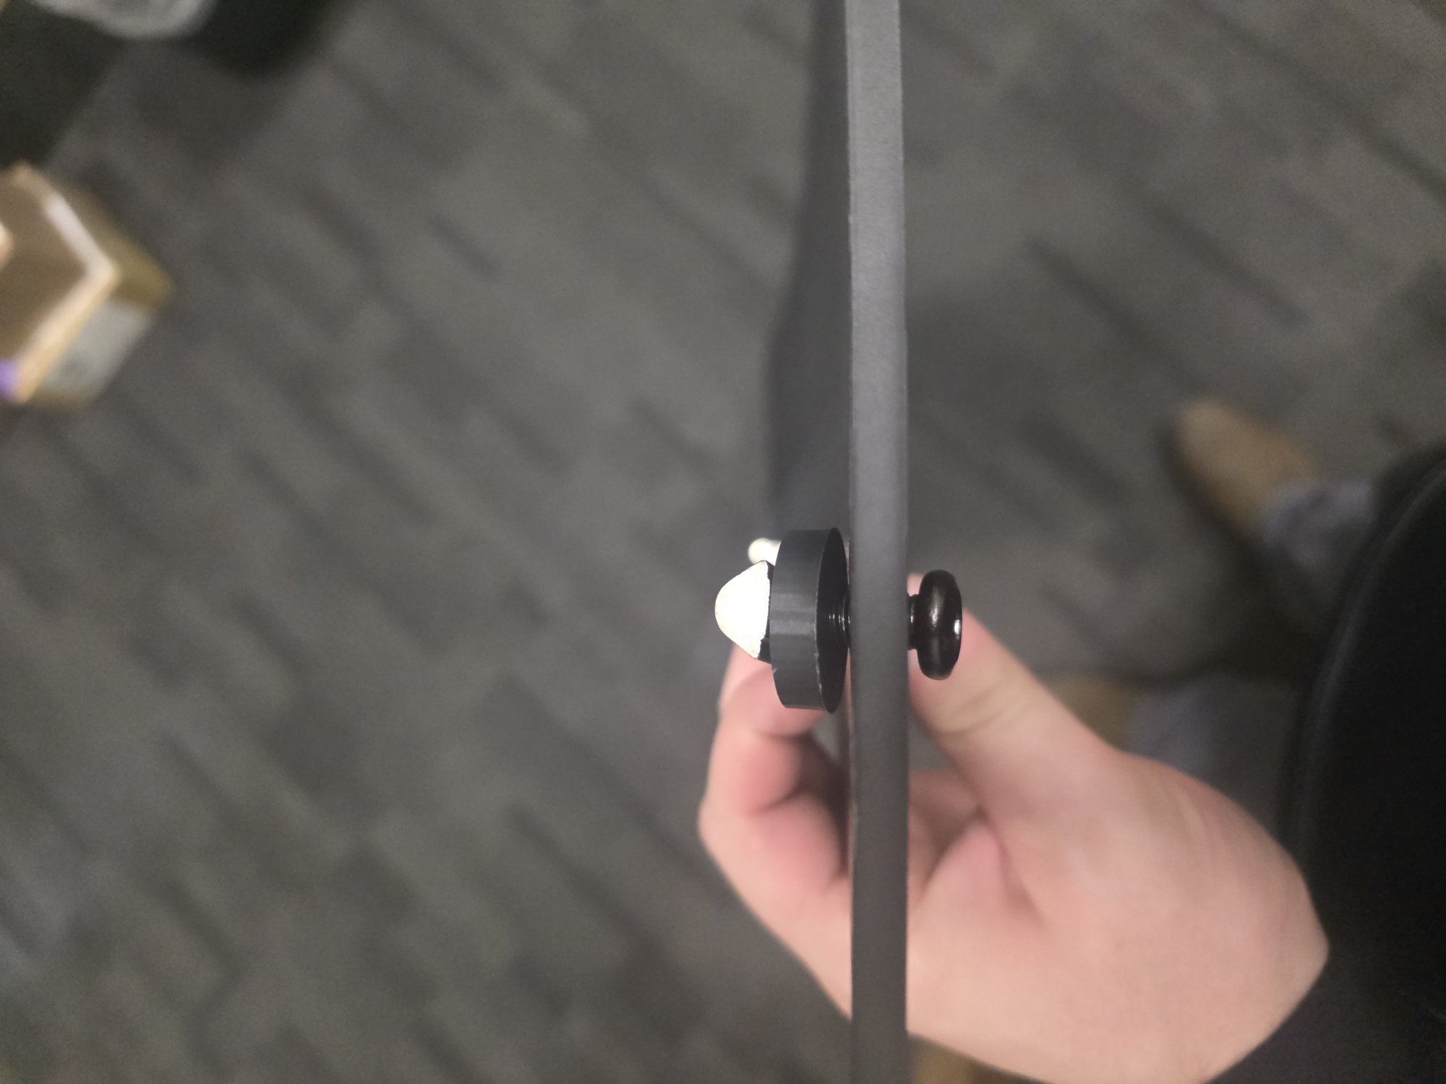
Figure: Side view of bolt, spacer, and T-nut assembly on the panel

Step 3: Attach Extrusion to Panels
- Lay the panels on the floor with the T-nuts facing upward.
- Slide the aluminum extrusion(s) onto the T-nuts one at a time.
- If Loctite is being used: apply to the bolt threads between the T-nut and the spacer at this stage.
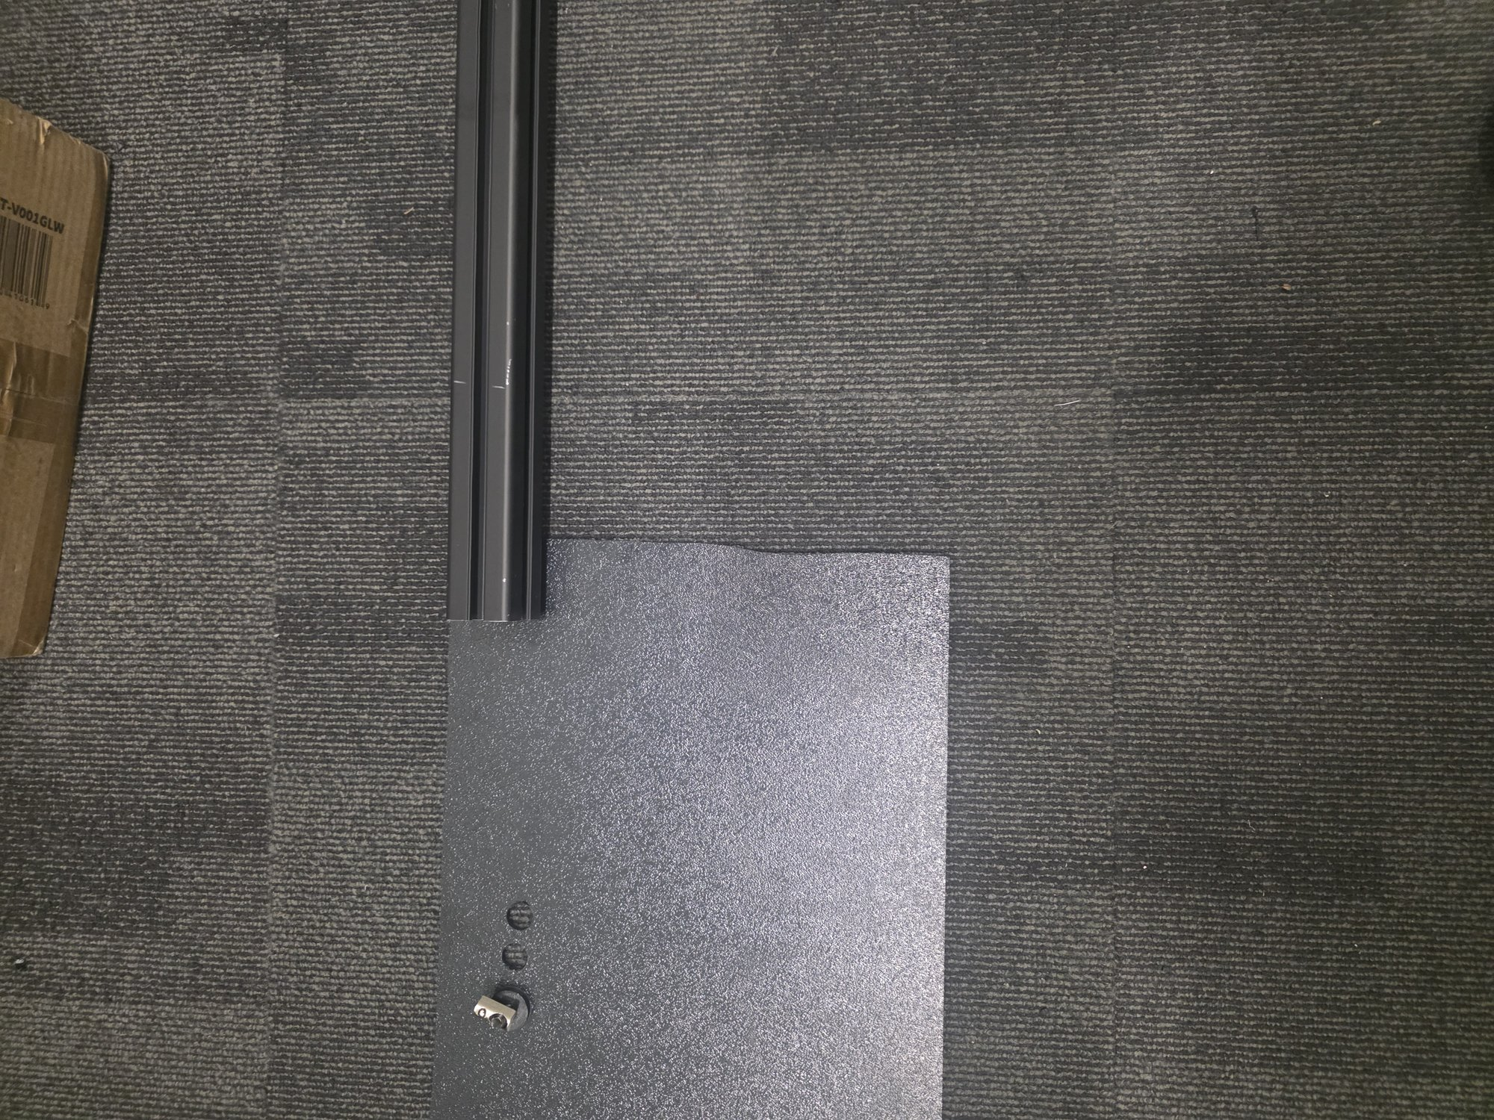
Figure: Sliding the aluminum extrusion onto the T-nuts (panel laid flat, T-nuts facing up)

Step 4: Tighten
- Stand the assembly upright and verify panel positions are correct.
- Tighten all bolts to final tightness. Recommended torque: 4 N·m for T-nut bolts in the extrusion. Same torque may be used on panel aligner bracket bolts as long as it does not crack the PLA.

Step 5: Install Panel Aligner Brackets
- Panel aligner brackets go on the back side of the panels (facing away from the conveyor).
- The brackets have rectangular cutouts that T-nuts fit into — use T-nuts in place of regular nuts (reduces unique hardware needed).
- Insert M8 bolts through the counterbored holes in the panels, through the bracket holes, and into the T-nuts.
- Tighten until panels are flush and co-planar at the joints.
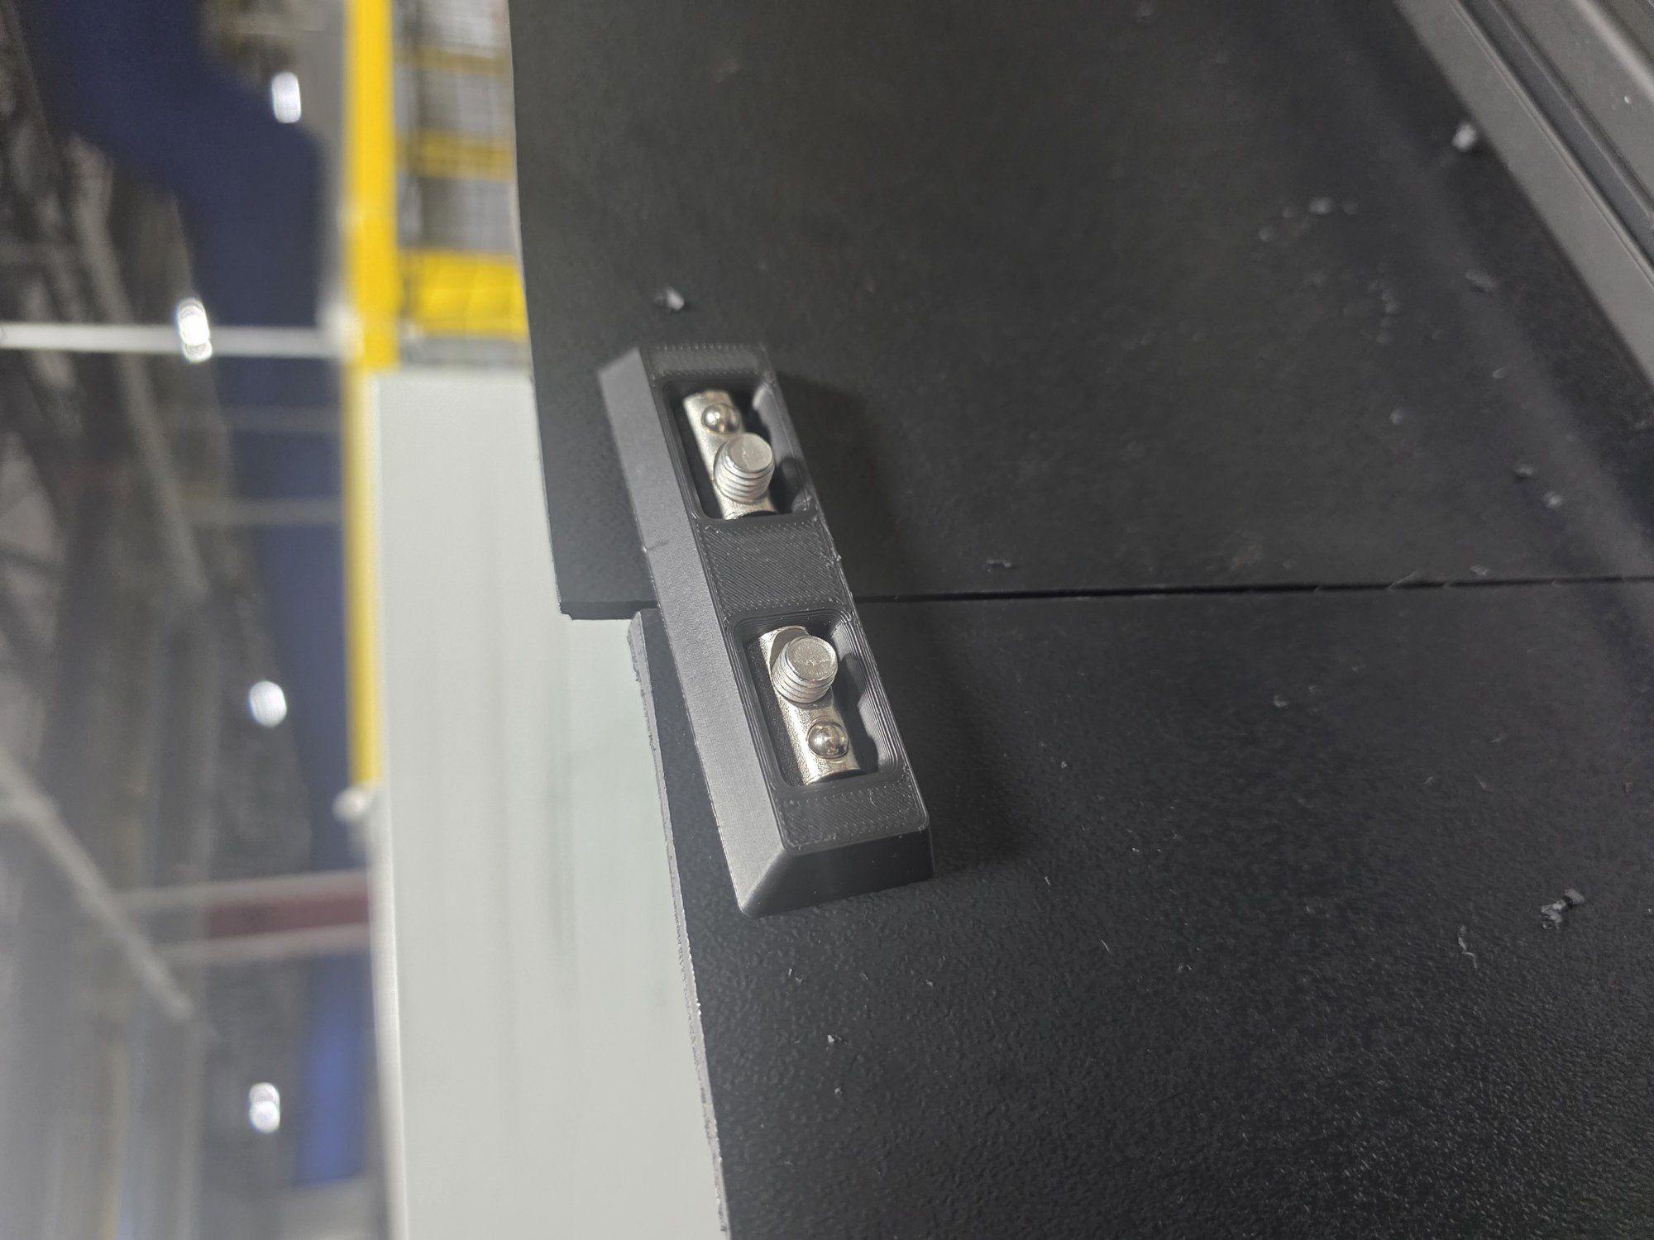
Figure: Panel aligner bracket installed at panel joint (back side of assembly)

Step 6: Install on Conveyor
- Two technicians recommended to carry the completed assembly to the install location.
- Follow LOTO procedures as required before working near the conveyor.
- Place the assembly on the conveyor mounting brackets.
- Slide a T-nut in from each end into the bottom-facing T-slot of the aluminum extrusion.
- Line up each T-nut with the desired slot position on the mounting bracket.
- From below the bracket, insert M8 screws upward into the T-nuts.
- Tighten until the assembly is rigid and does not wobble or slide along the slot.
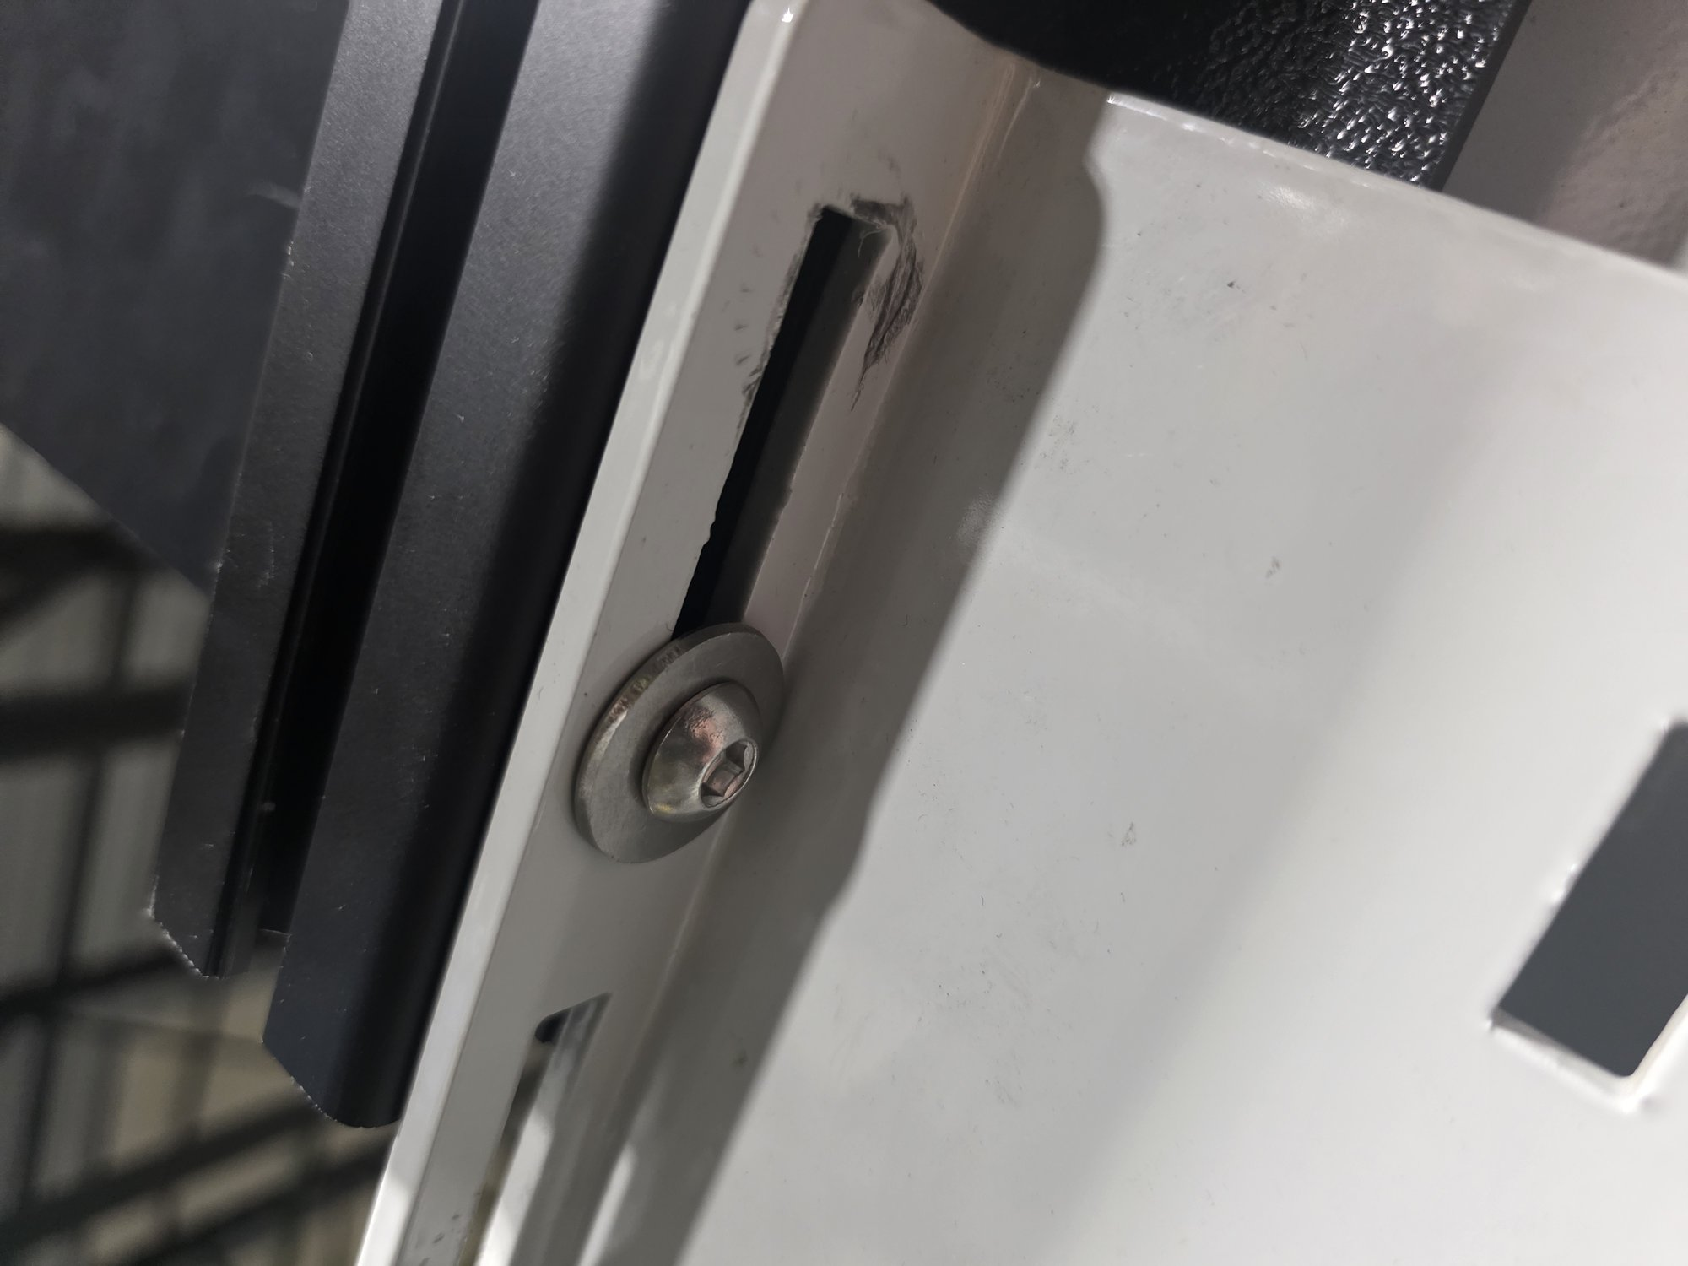
Figure: Underside view — M8 bolt through existing L-bracket slot into T-nut in bottom channel of extrusion

VIII. Maintenance and Inspection
Monthly visual inspection:
- Check mounting bolts for loosening — re-tighten as needed (4 N·m recommended)
- Inspect ABS panels for cracks or deformation from repeated package impacts
- Verify T-nut bolts remain tight and panels are secure
- Confirm linear connector joints are secure and extrusion sections are aligned
- Individual panels can be replaced without disassembling the full rail
Note on Loctite: Loctite 242 (blue, medium-strength) may be applied to mounting bolt threads if vibration-induced loosening is observed during operation. If used, it must be reapplied each time a bolt is removed and reinstalled.

IX. Configuration Tool — Updating and Maintenance
The Configuration Tool is a standalone HTML file containing all code in a single file. It was developed using Amazon Quick (AI assistant). To make updates, fix bugs, or add features:
1. Open a new Amazon Quick AI chat session.
2. Upload both the Configuration Tool HTML file AND the knowledge transfer file (SLAM Config Tool — Knowledge Transfer.txt).
3. Describe the desired change, bug fix, or new feature in plain language.
4. The AI will modify the HTML file directly, maintaining consistency with the existing code.
5. Open the modified HTML file in a browser and perform a hard refresh (Ctrl+Shift+R) to verify.
The knowledge transfer file contains the complete technical context, architecture, and design decisions. It ensures continuity regardless of who handles the update. No programming knowledge is required — describe problems or desired changes in plain language.
If an update breaks the tool, the backup copy ("DO NOT EDIT" version in the same folder) can be used to restore the last known-good version.

The following SLAM lines are recommended for guard rail installation, ordered by drop frequency (highest priority first). Each line has approximately 3 unguarded gap locations.

X. Priority Locations for Phase 2
Priority | Line | Notes
1 | Line 303 | Highest observed drop counts
2 | Line 305 | Second highest volume
3 | Line 108 | Third highest — previously highest single-line, recent RME work
4 | Line 304 | Moderate volume
5 | Line 502 | Moderate volume
6 | Line 501 | Remaining 2 gaps (1 already covered by prototype)
7 | Line 106 | Lower volume
8 | Line 107 | Low volume
9 | Line 105 | Very low volume — may not justify installation
Note: Line 501 already has the prototype installed at 1 of 3 locations. The remaining 2 gaps on Line 501 should also be covered.

XI. Leftover Parts from Initial Order
The following parts remain from the initial prototype order and are available for future installations:
Part | Quantity | Notes
M8×25mm Button Head Bolts | 19
M8×25mm Flat Head Bolts | 25
M8 T-Nuts (40-series) | 19
Linear Connectors (with set screws) | 2
6mm Printed Spacers | 4 | PLA
Printed Panel Aligner Brackets | 4 | PLA
Note: Counterbore bits (3/4") will need to be sourced again for future installations — they were consumed during the prototype build.

